SEL 703 – Internship Engineering
Ripudaman Thind

SmartHealth Band
A Wearable Sensor System with On-Device Analytics and Web Dashboard for Everyday and Health Monitoring

Overview:
This project develops a low-power wearable device that continuously monitors basic physiological and activity signals such as heart rate and steps, and transmits them to a web-based dashboard. Lightweight algorithms or ML models will run on the device and/or backend to derive higher-level health indicators (e.g., stress level, activity intensity, adherence to movement goals). The system is designed for both everyday users and patients, providing a generic but extendable platform for health and wellbeing monitoring.

Background / Problem
Instead of sporadic clinic visits, modern lifestyles and chronic health issues (such as cardiovascular risk, sedentary behavior, and stress) necessitate ongoing, inconspicuous monitoring. There are a lot of commercial wearables available, but they are frequently closed ecosystems, have limited customization options, and are difficult to incorporate into clinical or research processes. A versatile, open, and inexpensive wearable platform that can gather multi-modal physiological and activity data, apply lightweight algorithms or machine learning models, and display trends on a web dashboard for both general users and patients under supervision is required.

AIM
The objective of this project is to design, implement, and assess a microcontroller-based wearable health monitoring system that can reliably transmit the processed data to a cloud-connected web dashboard, perform on-device preprocessing and analytics, and track fundamental signals like heart rate, step count, movement, and basic derived metrics. In addition to being appropriate for use as a data source in clinical or research settings, the system should be sufficiently general for tracking daily wellness.

Block Diagram
[Sensors] → [Wearable Microcontroller + Edge Processing] → [Wireless Link] → [Gateway Device] → [Backend Server + Database + ML] → [Web Dashboard] → [User / Clinician]

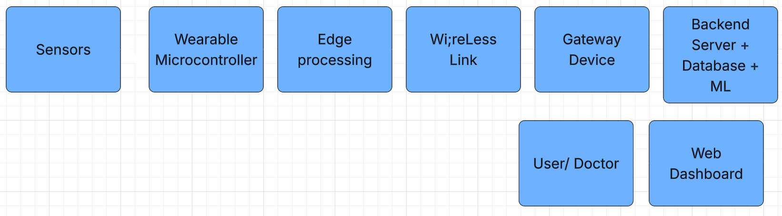

Use-Cases
To meet practical industry demands, this project creates a wearable health monitoring system that combines sensing, embedded processing, data analytics, and web-based visualization. Through continuous physiological and activity data collecting, lightweight algorithmic or machine learning-based analysis, and secure data presentation via a web dashboard, the system is intended to assist both routine wellbeing monitoring and patient-oriented observation. The project clearly relates to the digital health, workplace wellness, and health technology sectors by showcasing the useful application of software engineering, IoT, and data analytics abilities in a professional setting.
Key Industries:
- Personal Health and Wellness: Tracking daily well-being and lifestyle awareness through heart rate, steps, and activity trends.
- Patient and Assisted Care Monitoring: Constant, non-invasive monitoring of physiological and activity patterns to provide clinicians and caregivers with insights based on trends rather than diagnoses.
- Workplace Health and Safety: Examining physiological load and activity levels to enhance efforts to prevent injuries and raise awareness of weariness.
- Research and Innovation: An open, expandable wearable platform that can be used for testing, data-driven research, and assessing machine learning models and embedded algorithms.

Components Researched

Category | Component | Purpose in System | Available Options / Types | Why This Is Chosen / Notes
Microcontroller | ESP32 / ESP32-S3 | Main controller; sensor data collection, processing, wireless communication | ESP32-WROOM-32, ESP32-S3 | Built-in Wi-Fi + BLE, sufficient RAM for edge ML, low cost, industry-standard for IoT [1]
Heart Rate Sensor (PPG) | MAX30102 / MAX30105 | Measures heart rate (and optional SpO₂) using photoplethysmography | MAX30102, MAX30105 | Widely used in wearables, accurate, compact, well-documented [2]
Motion Sensor | Accelerometer / IMU | Step counting, activity detection, movement analysis | MPU6050, LIS3DH, LSM6DS3 | Enables step detection and activity classification; LIS3DH is low-power
Temperature Sensor | Skin / Body Temperature Sensor | Tracks basic physiological temperature trends | MCP9808, MLX90614, NTC Thermistor | Adds health context; improves activity and stress interpretation
Power Source | Li-Po Battery (3.7V) | Portable power supply for wearable | 500mAh–1000mAh Li-Po | Rechargeable, compact, suitable for wearables
Battery Charging Module | Charging & Protection Circuit | Safe charging and battery protection | TP4056, MCP73831 | Prevents over-charging/discharging; essential for real device safety
Voltage Regulation | 3.3V Regulator (LDO) | Stable power for MCU and sensors | AMS1117-3.3, low-dropout LDOs | Ensures reliable sensor readings and MCU stability
Wireless Communication | BLE / Wi-Fi (on ESP32) | Data transmission to gateway/backend | BLE GATT, Wi-Fi TCP/HTTP | BLE for low power; Wi-Fi for simple demos and direct backend access
Display (Optional) | OLED Display | Real-time feedback (HR, steps, status) | 0.96” SSD1306 OLED | Improves usability and device realism
User Input | Push Button / Switch | Start/stop logging, user interaction | Tactile button, slide switch | Simple control for marking events or power
Haptic Feedback | Vibration Motor | Alerts and notifications | Coin vibration motor | Enhances user experience without screen dependency
Storage (Optional) | Local Data Storage | Offline data logging | MicroSD card module | Useful for testing, debugging, and data redundancy
Speech Input (Optional) | Microphone Module | Voice/speech capture (advanced feature) | INMP441 (I2S mic) | Enables speech-based psychological analysis (usually via gateway)
Gateway Device | Phone / PC / Raspberry Pi | Receives wearable data and forwards to backend | Android phone, Laptop, Raspberry Pi | Reduces wearable complexity; enables heavier ML
Backend Server | API + Database | Data storage, analytics, ML processing | Node.js / FastAPI, MongoDB | Scalable, industry-relevant backend architecture
Web Dashboard | Frontend Application | Data visualisation and monitoring | React, Next.js | Real-time charts, summaries, professional UI
Enclosure | Wearable Case | Protects electronics and allows wearing | 3D-printed case, enclosure box | Makes prototype a real wearable device
Strap / Mounting | Wrist / Body Mount | Attaches device to user | Watch strap, Velcro strap | Required for practical wearable testing

[3]

Recent wearable IoT research, where ESP32 has been used to interface with biomedical sensors and transmit real-time health data in wearable health monitoring prototypes, supports the system's decision to use an ESP32 microcontroller as the central processing unit with integrated Wi-Fi/BLE. [4]
Research utilizing DS18B20 temperature sensors and MAX30102 photoplethysmography (PPG) sensors for heart rate monitoring shows their usefulness and dependability in comparable IoT wearable applications.
[5]
Additionally, thorough analyses of wearable health systems contextualize the significance of combining several physiological sensors with microcontrollers to accomplish continuous health monitoring in applications targeted at both patients and consumers.
[6]

For Alzheimer’s patients:

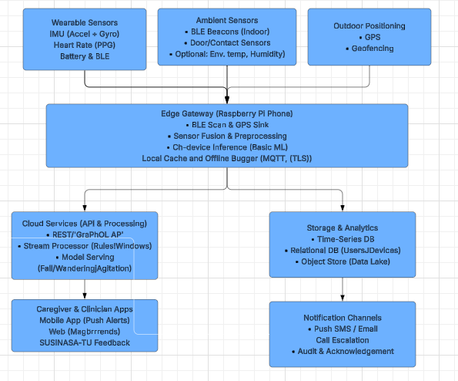

References
[1] J. Landa, G. Barrios, and G. Huelsz, “IoT smartwatch based on open technologies for the collection of thermal comfort data,” HardwareX, vol. 22, p. e00633, Jun. 2025, doi: 10.1016/J.OHX.2025.E00633.
[2] M. Pawar, S. Rusia, S. Tijare, A. Gadpalliwar, M. Ashtekar, and R. Pichkate, “Development of Health Monitoring Wearable Device using ESP32,” International Congress on Information and Communication Technology, pp. 2007–2012, 2024, doi: 10.1109/ICICT60155.2024.10544910.
[3] “(PDF) Integrating Wearable Health Monitoring Devices with IoT for Enhanced Personal Health Management: A Comprehensive Review.” Accessed: Dec. 14, 2025. [Online]. Available: https://www.researchgate.net/publication/382878497_Integrating_Wearable_Health_Monitoring_Devices_with_IoT_for_Enhanced_Personal_Health_Management_A_Comprehensive_Review
[4] “(PDF) Integrating Wearable Health Monitoring Devices with IoT for Enhanced Personal Health Management: A Comprehensive Review.” Accessed: Dec. 14, 2025. [Online]. Available: https://www.researchgate.net/publication/382878497_Integrating_Wearable_Health_Monitoring_Devices_with_IoT_for_Enhanced_Personal_Health_Management_A_Comprehensive_Review
[5] “Ejournal.” [Online]. Available: www.circuitdigest.com
[6] “(PDF) Integrating Wearable Health Monitoring Devices with IoT for Enhanced Personal Health Management: A Comprehensive Review.” Accessed: Dec. 14, 2025. [Online]. Available: https://www.researchgate.net/publication/382878497_Integrating_Wearable_Health_Monitoring_Devices_with_IoT_for_Enhanced_Personal_Health_Management_A_Comprehensive_Review

